Interpretable Multivariate Survival Models: Improving Predictions for Conversion from Mild Cognitive Impairment to Alzheimer’s Disease via Data Fusion and Machine Learning

Jorge Orozco-Sanchez1, Gerardo Fumagal González1*, Diana Rosales-Gurmendi1, Joshua Farber2, Victor Treviño1, Emmanuel Martinez-Ledesma1, Antonio Martinez-Torteya3, Jose Tamez-Peña1,2

1Tecnologico de Monterrey, Monterrey, Mexico

2Qmetrics Technologies LLC, Rochester, NY, USA

3Departamento de Ingeniería, Universidad de Monterrey, Monterrey, Mexico;

**\* Correspondence:**Gerardo Alejandro Fumagal González  
gerardofumagalgzz@gmail.com

Keywords: qMRI, Alzheimer’s disease, Survival, Cox, Machine Learning, Radiomics

# Abstract

Accurately predicting which individuals with mild cognitive impairment (MCI) will progress to Alzheimer’s disease (AD) can improve patient care. This study examines the role of quantitative MRI (qMRI), cognitive assessments, Apolipoprotein E4 (APOEε4), and cerebrospinal fluid (CSF) biomarkers in Cox survival models for predicting the progression from MCI to AD. Data from 564 participants in the ADNI study, who transitioned from MCI to AD, were analyzed. The dataset included 330 features encompassing qMRI, cognitive assessments, CSF biomarkers, and APOEε4 status. Advanced machine learning (ML) methods were applied to evaluate the importance of these data sources, select relevant features, and develop interpretable Cox survival models within a cross-validation framework. The top optimized model achieved a sensitivity of 0.69, 95% CI [0.63,0.76] and a specificity of 0.87, 95% CI [0.83,0.90] and used all data sources. The results demonstrated that combining qMRI features with cognitive assessments, CSF biomarkers, and APOEε4 status significantly improves the ability to predict MCI-to-AD progression. Finally, the biomarker analysis yielded that Cognitive scores are the most relevant in features in predicting conversion, followed by CSF and qMRI biomarkers. These findings highlight the value of integrating multiple data sources in highly interpretable Cox survival models for the early identification of individuals at risk for Alzheimer’s disease.

# Introduction

Alzheimer's disease is one of the most common cognitive disorders in old age (1). The development of effective treatments or disease-modifying therapies is hampered by the complexity of aging and the lack of a clear understanding of the etiology and pathogenesis of AD (2). The diagnosis of AD in the early stages of the disease is complex. The most accurate AD diagnostic test requires a histopathological evaluation of brain tissue by autopsy or biopsy (3). Without a biopsy, the diagnosis of a normal patient is defined as possible or probable AD according to patient reports, cognitive observation, and symptomatology (4). Hence, understanding the process and each of the stages of AD is essential for developing effective treatments. It is noteworthy that mild cognitive impairment (MCI) is regarded as a transitional stage between normal aging and AD (5), therefore in the context of conversion of mild cognitive impairment (MCI) to AD, some biomarkers have been identified in the AD literature. The beta-amyloid and the tau proteins from the cerebrospinal fluid (CSF) (6,7), the scores in cognitive assessments (8), and the polymorphism of the fourth allele of the apolipoprotein E (APOE-4) (9) have been recognized as validated risk factors for the conversion. On the other hand, some studies have presented that clinical information and imaging biomarkers can be used to predict patients who will undergo conversion from those who will not (10). Imaging biomarkers related to AD have been found in PET and MRI and have a clear association with the evolution and presence of AD (11) and with the conversion of MCI to AD (12). However, the impact of imaging biomarkers to determine the conversion rate between MCI to AD, as well as the relationship and the importance of the qMRI features in survival models, have not been fully studied.

CSF biomarkers are increasingly being used to support a diagnosis of Alzheimer’s disease, especially to determine the difference between AD from non-Alzheimer's disease dementia (13–15). Different biomarkers can be extracted from CSF. The most established in the usual clinical practice include beta-amyloid 1-42 ($Aβ_{1-42}$), total tau (t-tau), and phosphorylated tau at threonine 181 (p-tau) (13). All of them have been previously described in AD pathogenesis. Despite their role in AD pathogenesis, the direct measurement of these CSF biomarkers lacks diagnostic accuracy (15,16).

Alternatively, the symptomatic AD process alters brain function; henceforth, cognitive assessments are usually the starting point for the brain health plan and are recommended for all patients who want to be screened for AD (17,18). These assessments evaluate some important areas of brain function, memory and reasoning capacity, concentration, processing speed, and language. Depending on the country, language, or type of test, several experts have developed and validated standard tests such as those used in this work. Some authors have updated and proposed changes in the normal cognitive assessments to better classify or predict the conversion in patients (19) and others proposed the combination of patterns of brain atrophy and cognitive assessment scores, the latter offering the highest predictive power for the conversion (20).

Other tests available for the understanding of the AD process are magnetic resonance imaging (MRI) and positron-emitting tomography (PET). These imaging modalities can visualize direct changes in brain structure, function, sugar metabolism, and AD build-up (21,22). Therefore, AD-related imaging biomarkers with a clear association with the early development and presence of AD have been discovered in MRI and PET (11). Furthermore, imaging biomarkers have been associated with the conversion from MCI to AD (23–27). Consequently, MRI and PET are commonly used to monitor the progression of the disease and to detect the current stage of neuronal degeneration (28).

Lastly, the onset of AD requires a clear description of its risk factors. Age and gender are established risk factors for developing AD. Older people are at higher risk, while women are more prone than men to developing AD. APOE4, the polymorphic allele of the apolipoprotein E, is a known genetic risk factor for developing AD (29). These known factors must be considered when developing screening or staging AD tests. Therefore, researchers have proposed the combination of risk factors, cognitive tests, MRI, and PET features with CSF biomarkers to improve the diagnosing accuracy of AD, and to improve the predicting power of MCI to AD conversion (6).

The development of a good screening test requires the identification, characterization, and validation of biomarkers associated with AD and requires a good understanding of their evolution as well as their role in the disease process. Although there is plenty of research describing the association between biomarkers at the MCI stage and probable AD conversion, their discoveries have not effectively evaluated the time required from MCI to AD conversion. (29-31). This evaluation is important because some biomarkers may be associated with a slow conversion process (low-risk markers) while others with a swift conversion (high-risk markers) (32). In this context, multivariate Cox regression models are a statistical tool that can be used to screen out low-risk markers vs. high-risk markers. Cox modeling incorporates the time to event in their fitting process and provides estimates of the hazard ratios (HR) of each potential biomarker. This feature of Cox modeling can be used to improve the understanding of biomarkers associated with the AD process. In addition, Cox proportional hazard has been widely used in survival studies (33).

The challenge of Cox modeling in biomarker discovery is that thousands of potential biomarkers can be associated with the risk of conversion. Traditional approaches use hypothesis-based feature selection; thus, findings have been limited to a small set of biomarkers (34). Alternatives to the traditional approach are subset selection and regularization. Subset selection is based on computer algorithms that attempt to identify the best set of features associated with the disease process. Regularization methods use all the available features to estimate the total multivariate risk, and they solve the ill-posed problem by adding heuristic constraints. Statistical learning (SL) and machine learning (ML) strategies provide efficient and highly competitive regularization and subset selection methods. Embedded SL approaches like L1 regularization via LASSO or L2 regularization through RIDGE allow the exploration of multivariate models composed of hundreds of features (37). L1 regularization via the LASSO also allows subset selection (38). Bootstrap Step-Wise Model Selection (BSWiMS), golden section primal-dual active set (GPDAS), and sequential primal-dual active set (SPDAS) are other subset selection methods readily available to researchers (38,39). Finally, researchers usually rely on traditional statistical methods controlled for false discovery rate (FDR) for feature selection (FS) (40,41).

The wide variety of methods available to researchers can make biomarker discovery a complex effort, especially when there is no clear choice of methodology for building/exploring survival models. To overcome this limitation, we propose a unified approach for the study of Cox models in an ML setting. The approach is based on repeated cross-validating ML methods using the same training-testing sets across all the methods. The implementation evaluates LASSO, RIDGE, BSWiMS, GPDAS, and SPDAS, (42) and FDR-controlled univariate filtering for building suitable survival models. Thus, the result of the approach is a fair method comparison and a comprehensive evaluation of the role of each potential biomarker inside a Cox survival model. The primary goal of this paper is to provide a strict comparison of Cox models constructed from multivariate-multi-data sources (Imaging, Risk factors, CSF, and Cognitive Assessments) that describe the MCI to AD conversion risk for each subject in a unified approach. In addition, an important aim is to provide a unique consensus-based Cox model that can be used to accurately predict the chances of conversion of MCI-diagnosed subjects. Subsequent sections present the data preparation, the utility of the unified approach for the comparison of ML models, and the role of the top biomarkers associated with MCI to AD conversion.

# Materials and Methods

This study was based on the TADPOLE challenge data sets (https://tadpole.grand-challenge.org). The TADPOLE sets were derived from the ADNI study (adni.loni.usc.edu). The ADNI was launched in 2003 as a public-private partnership, led by Principal Investigator Michael W. Weiner, MD. The primary objective of ADNI has been to test whether MRI, PET, other biological markers, and clinical and neuropsychological assessment can be combined to measure the progression of mild cognitive impairment (MCI) and early Alzheimer’s disease (AD). For up-to-date information, see [www.adni-info.org](http://www.adni-info.org)

The ADNI/TADPOLE challenge datasets considered for this study were: “D1 - a comprehensive longitudinal data set for training”, and “D2 - a comprehensive longitudinal data set on rollover subjects for forecasting”. The challenge included 1,737 individuals from the ADNI database with longitudinal observations. Each subject’s data included the diagnosis status, cognitive assessments, qMRI and PET data, and APOE4 status. Detailed information regarding the rationale and the features contained in the TADPOLE challenge can be found Marinescu et.al (41).

Figure 1 shows the inclusion exclusion criteria used in this study. We screened for features that were common among the TADPOLE individuals (>30%), and whose baseline evaluation yield MCI status. Figure 2 shows the procedure used to assess the difference between groups in the study and to evaluate the importance of features. First, we preprocessed the data. Then, we evaluated the potential to discriminate between stable MCI subjects and converters using a variety of machine learning methodologies. After that, we divided the features into three major groups. The features detailing levels of three different proteins, $Aβ_{1-42}$, t-tau, and p-tau were included and studied in a group labeled as CSF features. These measures were obtained during baseline evaluation at the University of Pennsylvania Medical Center. Next, we included information from several neuropsychological tests, labeling the entire group of features as Cognitive Assessment features. Due to the nature of the disease, an ADNI examiner interviewed the patient to determine all the cognitive assessment scores. A complete description of the assessment acquisition is found in the ADNI manual. Seven assessments were used: Clinical Dementia Rating Sum of Boxes (CDRSB) (44), Alzheimer’s Disease Assessment Scale (ADAS) (45), Mini-Mental State Examination (MMSE) (46), Rey's Auditory Verbal Learning Test (RAVLT) (47), and Functional Assessment Questionnaire (FAQ) (48). The 346 qMRI measurements provided by the University of California San Francisco (UCSF) were included and labeled as Radiomic features. UCSF used FreeSurfer Version 4.3, for the analysis of the MRI data sets (49). Finally, sex and APOE4 status was also included in this group. Table 2 shows the descriptive characteristics of the main features of the dataset.

## Data conditioning and pre-processing

We computed the time to conversion from the provided data. The event time for subjects that converted consisted of the difference in days between the date of their first AD diagnosis and the baseline date. The event time for stable MCI subjects consisted of the difference in days between the date of the baseline and the date of the last recorded follow-up visit. MCI-stable subjects were labeled as censored. We pre-processed the radiomic features as follows: We compute the cubic root of all qMRI volumes, and the square root of all qMRI areas. All qMRI data was normalized by dividing each one by intracranial volume. After that, the qMRI measures of left and right sides of the brain were described by the mean and absolute differences, and relative differences. Hence, these last features can be used to check dementia issues due to brain asymmetry.

## Cox modeling via Machine Learning Subset Selection

To explore the subset of features and its association with the MCI to AD conversion we used machine learning to train Cox regression models. Cox models explore the relationship between the time of the event and the possible explanatory variables. The model estimates the hazard, $λ_{i}$, of the subject $i$ given the observed feature vector $X_{i}=\left\{X_{i1},…,X_{ip}\right\}$, and the unknown baseline hazard $λ\left(t_{0}\right)$, i.e.:

$λ_{i}\left(t | X_{i}\right)=λ\left(t_{0}\right)e^{X_{i}∙β}$ (1)

where $β=\left\{β_{1},…,β_{P}\right\}$ is the vector of coefficients. The fitting is commonly performed by a maximum likelihood estimation method providing the $β$ values and relative hazard ratios. Thus, the Cox model provides an estimate of the total hazard or risk of conversion, given the observed features for an individual. Due to the large set of possible qMRI features to be considered in some of the Cox models, ML methods were used to find an optimal set of features and their corresponding coefficients that mimicked the observed rate of conversion.

There are several strategies for building Cox models (50–54). In this paper, we evaluated three open-source ML packages. These packages provided us with different strategies for building Cox models. The first ML method was BSWiMS, part of the FRESA.CAD R package (50), is a supervised model-selection method aimed at generating a unique statistical model that predicts a user-specified outcome, in this case, a survival outcome. The statistical model is constructed by bagging a set of Cox models where each Cox model is composed of a set of model-wise statistically significant features (55). The second evaluated package was the gmlnet R package that implements the Penalized Cox Regression (CoxNet) algorithm. CoxNet fits the Cox model regularized by L1 or L2 or a mixture of them using the elastic net penalty (37). We executed CoxNet with their provided 10-fold cross-validation function (cv.glmnet) to determine the optimal weight of the regularization constraint. Furthermore, we ran cv.glmnet with two alpha values: alpha=1 (Feature selection with LASSO regularization), alpha=0 (Ridge or L2 regularization). The third evaluated package was the BeSS R package. This package implements the Golden Section Primal-Dual Active set algorithm (GSPDAS) aiming for the selection of the best set of features of the Cox model. Like CoxNet, BeSS can use different strategies for subset selection. The default configuration uses the GSPDAS algorithm (38). The second BeSS option is SPDAS based on the Bayesian information criterion (BIC) (56). The third option runs SPDAS algorithm with the EBIC. In summary, we evaluated six different Cox models: BSWiMS, LASSO, RIDGE, BESS:BIC, BESS:EBIC, and BESS:GS.

## Cox Model Validation and Evaluation

The main aim of this paper is the comprehensive evaluation of the Cox models for the prediction of the MCI to AD conversion. To achieve this goal, we constructed a fair playground where the same repeated holdout cross-validation (RHOCV) approach was used for the evaluation of the different ML strategies on the different sets of features provided by the TADPOLE challenge. The test results of the RHOCV were used to compare and explore the performance of the ML alternatives. The RHOCV strategy is part of the FRESA.CAD R package. The RHOCV method creates multiple sets of training and testing sets. At each interaction, the input data is randomly divided into a training and testing set. The training set is used for the model or feature selection, while the holdout set is predicted by the trained method (55). Once all the holdout predictions are generated, the test results are evaluated and compared between ML strategies. The RHOCV implementation uses the Survival R package to calculate the final Cox predictions of each model.

The estimated coefficients $β^{j}$ on each training set ${\text{T}}_{\text{j}}$ were used to get the subject ***i*** linear predictions $f_{i}^{j}$ of the holdout set ${\text{T}}_{j}^{c}$ at each repetition:

$f_{i}^{j}=X_{i}∙β^{j}, ∀ i ∈{\text{T}}_{j}^{c} and ∀X_{i}∈ A_{j}$ (2)

Once the linear predictions were obtained for each repetition, the test results were ensembled by computing the median prediction for each subject as ${\tilde{f}}_{i}=\text{median}\left(\left\{f_{i}^{1},…,f_{i}^{R}\right\}\right)$. The ensemble prediction was used to divide the subjects into high-risk (HR: $\tilde{f}≥t_{o}$) and low-risk (LR: $\tilde{f}<t_{o}$) groups, where $t_{o}$ is the decision threshold. We assumed that censored subjects belong to the low-risk group, while true MCI to AD conversions are in the high-risk group. The receiver operating characteristic (ROC) plots and their area under the curve (AUC) with their corresponding 95% confidence intervals (CI) were computed for the risk prediction using the pROC package (58). Accuracy (ACC), sensitivity (SEN), and specificity (SPE), describing the ability of the Cox models to predict censored vs. uncensored subjects were computed based on the number of true positives (TP) and true negatives (TN).

(3)

(4)

(5)

(6)

(7)

$TP=\left|\left(\tilde{f}≥ t_{o}\right)∩ \text{uncensored}\right|$ (3)

$TN=\left|\left(\tilde{f}< t_{o}\right)∩\text{censored}\right|$ (4)

$ACC=\frac{TP + TN}{\left|uncensored+censored\right|}$ (5)

$SEN=\frac{TP}{\left|\text{uncensored}\right|},$ and(6)

$SPE=\frac{TN}{\left|\text{censored}\right|}$. (7)

The survival performance was evaluated using the concordance index (c-index). The c-index measures the fraction of all order pairs of subjects $ε_{ij}$ Whose predicted survival times are correctly ordered among all subjects that can be ordered. It can be written as:

$c=\frac{1}{\left|ε\right|}\sum_{t_{i}∈\text{ uncensored}}{\sum_{t_{j}>{ t}_{i}}{1_{{\tilde{t}}_{i}<{\tilde{t}}_{j}}}}$, (8)

where the indicator function $1_{a<b}=1$ if $a<b$, and 0 otherwise. $\left|ε\right|$ is the number of ordered pairs. ${\tilde{t}}_{i}$ is the median of the predicted survival time, and $t_{i}$ is the actual observed time of the uncensored subject $i$. The values of the c-index range from 0 to 1, where 1 implies a perfect concordance between observed and predicted times.

We evaluated the prediction benefit using decision curve analysis (DCA). The DCA curves indicated net benefit of the predicted probability of the models. The analysis of the predicted probability was used to estimate the high-risk threshold at 90% specificity and the middle-risk threshold at 80% specificity. The 90% threshold was then used to evaluate the classification performance of the models.

The visualization of the predicted survival groups, high-risk vs. mid-risk, and low-risk, was done using Kaplan-Meier (KM) plots of survminer R package (59). The statistical significance of the difference between the survival groups was evaluated by the Logrank test (60):

$Z=\frac{\sum_{i=1}^{N}{\left(O_{HRi}-E_{HRi}\right)}}{\sqrt{\sum_{i=1}^{N}{V_{i}}}}\overset{d}{→}N\left(0,1\right)$, and (9)

$V_{i}=\frac{O_{i}\left(\frac{N_{HRi}}{N_{i}}\right)\left(1-\frac{N_{HRi}}{N_{i}}\right)\left(N_{i}-O_{i}\right)}{N_{i}-1}$, (10)

where $O_{i}$ is the actual number of events, $N_{i}$ is the number of subjects below rank, and $N_{HRi}$ is the number of subjects at high risk.

We validated and evaluated the six Cox models using the RHOCV procedure with 50 random repetitions. Each run used 70% of the subjects for training while 30% was used for testing. The procedure builds models selecting features in each run; hence the analysis plan included the exploration of the common top features discovered in each experiment.

## Features Source and Cox-Models

The next set of experiments executed the independent RHOCV experiments using the BSWiMS to explore the impact of data sources. Experiment 1 used CSF and APOEΕ4 features. Experiment 2 studied six Cognitive Assessment features. Experiment 3 constructed models from the MRI and APOEε4. Experiment 4 used Cognitive Assessment and MRI. Experiment 5 used all the features from CSF, Cognitive Assessment, MRI, and APOEε4as part of the feature set. Each experiment consisted of the independent execution of the RHOCV procedure 50 times. Each run used 70% of the subjects for training while 30% was used for testing. The procedure builds models selecting features in each run; hence the analysis plan included the exploration of the common top features discovered in each experiment.

## Biomarker Evaluation via Model Feature Analysis

The last experiment was designed to explore the hazard ratios of the top Cox model features associated with the MCI to AD conversion. First we set the training (70%) and testing sets(30%). Then we z-standardized all features using the training set to estimate the mean and variance of the continuous features and estimated the z-scores of the testing set. After that, we run the BSWiMS procedure for 20 Cox bootstrap estimations using the training set and evaluating the performance on the testing set. The summary method of the BSWiMS analyzes the hazard ratio of each fitted model and reports their 95% Confidence intervals for each one of the top features associated with conversion.

# Results

## ML Feature Subset Selection Method

Table 3 shows the ROC ACU, the c-index, the accuracy, the sensitivity, and the specificity of all six evaluated ML methods on the testing sets. Figure 3(a) shows the ROC curve of all the evaluated ML methods, while Figure 3(b) shows the decision curve analysis (DCA) and the Kaplan-Meier of the BSWiMS, BESS:BIC, and LASSO test results. The BSWiMS model showed a test performance with AUC 0.87, 95% CI [0.85,0.90], SEN 0.69, 95% CI [0.63,0.76], SPE 0.87, 95% CI [0.83,0.90]. The LASSO model also showed an equivalent performance, with AUC 0.88, 95% CI [0.85,0.90], SEN 0.64 95% CI [0.57,0.71], and SPE 0.87, 95% CI [0.83, 0.90]. The BSWiMS and LASSO were statistically similar with the advantage that BSWiMS models’ coefficients are highly interpretable. The BeSS models, and RIDGE regression did not produce results as good as the LASSO and BSWiMS. These models were statistically inferior to the BSWiMS methods, furthermore, the DCA analysis indicated an inferior benefit to predict subjects that will convert to AD. The worst performing method was the RIDGE method, whose ROC AUC was 0.54 95%CI [0.49,0.58]. All models were able to stratify the high-low risk groups with statistical significance.

## Features Source and Cox-Models

Table 4 reports the performance metrics of the Cox models for the five sets of data sources. Figure 4 shows the ROC AUC for all five sources as well as the DCA analysis, and Kaplan-Meier of the cognitive and CSF features. The model developed using CSF and qMRI data showed the lowest classification performance, with an AUC of 0.78 95% CI [0.74,0.82], and 0.79 95%CI [0.75,0.83] respectively. The cognitive model showed the best performance 0.84 95%CI [0.81,0.87] that was statistically superior to MRI and CSF models (p<0.001). The models that used multiple data sources were statistically superior to the cognitive only model. ROC AUC improved to 0.85, 95%CI [0.82,0.89] for the qMRI-Cognitive model and to 0.87, 95%CI [0.85,0.90] for the model that used all the data sources. All these models that fused data sources were statistically superior (p<0.01) to the models that only used a subset of features. The Kaplan-Meier analysis indicated that the model that used all the data sources (Figure 3b) showed subjects classified as low risk had a nice five-year non-conversion rate (87%) when compared to the high-risk group that by year 5 more than 80% of them have converted to AD.

## Biomarker Evaluation

Table 5 shows the beta coefficients their corresponding hazard ratios with their corresponding 95% confidence intervals of the features that statistically improved the Cox model for the accurate high-risk, low-risk classification task. The table shows that all data sources have features that aid the classification. The top feature was the Rey Auditory Verbal Learning Test: immediate that indicated that higher scores indicate subjects that will remain stable with a z-standardized HR of 0.527 95% CI [0.400,0.695]. The top CSF biomarker was the amyloid-β (Aβ), HR 0.679 95% CI [0.541,0.853], the APOEΕ4 showed an HR 2.063 95% CI [1.357,3.136]. The top qMRI feature was the Mean Volume of Left Entorhinal gray matter whose HR was 0.689 95%CI [0.557,0.852].

The top left heatmap of Figure 5 shows the heatmap of the top features and depicts features positively associated with conversion and the features with negative association to conversion. The graph at the bottom-left of Figure 5 shows the association of variables in predicting conversion. Two main cluster of variables were found: the first cluster includes amyloid-β (Aβ), FAQ and ADAS13, while the second cluster involves tau (p-tau), APOEΕ4, and ADAS11. The plots on the left side report the performance of the model on the testing set. The ROC curve, the DCA and the Kaplan-Meier show that the model created by standardized features had very similar performance as predicted by the RHOCV procedure.

# Discussion

## ML Feature Subset Selection

We validated that the integration of multiple biomarker modalities—CSF, APOEε4, MRI, and cognitive assessments— in Cox models for the predicting MCI-to-AD conversion is effective. Our validation was based on a stringent hold-out-cross validation scheme that randomly repeated the model training 50 times and analyzed the test results by advanced performance analysis methods like decision curve analysis, and Kaplan-Meier plots. This analysis indicated that machine learning models such as LASSO and BSWiMS demonstrated their capacity to capture complex biomarker interactions, improving diagnostic precision and enabling more personalized treatment strategies. Recent research by Liu et al. (61) also highlighted the utility of LASSO in AD prediction, particularly when used with multimodal data, supporting our findings. The model's capability to integrate cognitive and imaging biomarkers makes it well-suited for capturing subtle patterns indicative of early AD progression.

Similarly, the BSWiMS model also showed top performance, especially in its ability to be the best model to predict conversion at 90% sensitivity, yielding an AUC of 0.87 with a sensitivity of 0.69 95%CI [0.63,0.76]. Furthermore, the BSWiMS showed a strong net benefit in a threshold range of 0.2-0.7 further reinforces its reliability in clinical applications. As noted by Mito et al. (59), models that integrate structural MRI with other biomarkers, like BSWiMS, tend to provide higher predictive accuracy, particularly for identifying patients at high risk of AD conversion. The BSWiMS model's ability to stratify patients into distinct risk groups, as seen in the Kaplan-Meier analyses, makes it a valuable tool for early diagnosis and risk management in clinical practice. Overall, the performance of both LASSO and BSWiMS models validates the importance of multimodal approaches for accurate and clinically relevant AD prediction.

## Source Analysis

The study demonstrated the differences in AUC values across the five experimental data-source conditions, highlighting the varying predictive power of different biomarker combinations. The integrated model with all biomarker modalities (CSF, APOEε4, MRI, and cognitive data), achieved the highest AUC of 0.87, 95%CI [0.85,0.90], indicating that multimodal integration significantly improves classification accuracy. This result is consistent with recent studies such as Leuzy et al. (60), and Liu, M., et al. (61) which showed that combining multiple biomarker sources offers a more comprehensive understanding of disease pathology and leads to improved predictive performance. Conversely, models based on single modalities, such as CSF + APOEε4, and MRI+ APOEε4, displayed a lower predictive power, suggesting that single source biomarkers do not capture the full complexity of MCI-to-AD progression.

Comparing our methodology with a deep learning survival model, Mirabnahrazam et al. (64), worked with a deep learning-based survival model (DeepSurv) which included demographics, cognitive tests, genetic data, CSF biomarkers and MRI measures as their features, showed an accuracy of 0.83, while our best model BSWiMS achieved similar results: 0.81 95%CI [0.78-0.84] with the added advantage that the BSWiMS Cox model is highly interpretable.

## Cox Model Feature Analysis

This study validated many of the well-established predictors of MCI-to-AD conversion. Notable examples include p-Tau, Tau, APOEε4, Amyloid Beta, the Functional Activities Questionnaire, the Rey Auditory Verbal Learning Test, and specific brain regions such as the entorhinal and hippocampal cortices, as identified by Delli et.al (65), Varatharajah and Chen (62,66)

While our model aligns with recent studies in identifying several MRI features associated with MCI-to-AD conversion, it also highlights additional MRI features that emerged as significant, despite not being traditionally recognized as relevant indicators for this progression. For example, Varatharajah (62), identified the average cortical thickness in the superior frontal, medial orbitofrontal, caudal anterior cingulate, and isthmus cingulate regions as significant predictors. In contrast, our study highlights the significance of the mean volume in the cortical parcellation of the left superior frontal region, the mean surface area of the left medial orbitofrontal region, the mean cortical thickness standard deviation of the left caudal anterior cingulate, and relative difference on the volume from cortical parcellation on left isthmus cingulate as well as mean surface area of the same region. These differences highlight the importance of looking beyond average cortical thickness, considering instead localized asymmetries and alternative measurements, such as surface area and mean volume within cortical parcellations.

In a broader context of feature relevance, a systematic review by Muhammed et al.(63) identified that most studies prioritize MRI features, particularly entorhinal and hippocampal volumes, as key indicators for MCI-to-AD conversion. These features are also highlighted as critical components in our final model. Furthermore, the review indicates that many researchers combine structured data from multiple modalities. For instance, one study by Lei et al (67), used hippocampal volume as an MRI feature alongside A-beta as a CSF feature, while another study by Frolich et al (68), included hippocampal volume, tau, and A-beta as features for predicting conversion. These studies align closely with our findings, as we incorporate both hippocampal and entorhinal volumes as features. Additionally, our model leverages multimodal data by integrating MRI, CSF, cognitive, and genomic data, aligning with the multimodal approaches observed in related research.

## Limitations

The results presented in this work are limited to four key aspects. First, patient misdiagnosis is present, hence affecting feature selection and model building. The AD diagnosis used in this study is not definitive, but according to the NINCDS-ADRDA it is the probable diagnosis of AD with probable errors in 10% to 15% of cases (68). Second, the presented findings were based on the ADNI cohort and measurements; therefore, it is biased toward the environmental factors present in the US and the Caucasian race. Third, qMRI results were based on free-surfer analysis, hence changes in analytical tools may produce different results. Fourth, limited research has been done regarding the comparison of analytical techniques for automatic prediction of time to event within AD (68). These key limitations indicate that the presented findings must be confirmed on cohorts from different countries and ethnicities.

# Conclusion

This study showed that multi-modal biomarker integration and machine learning methods for the construction of interpretable Cox survival models are effective strategies in predicting the progression of mild cognitive impairment to Alzheimer's disease. We improved diagnostic accuracy significantly by combining CSF fluid, APOEε4 genotype, MRI, and cognitive tests over single-modality models. In particular, the LASSO and BSWiMS models performed admirably in identifying complicated biomarker relationships and stratifying patients into separate risk categories. Notably, the discovery of unique MRI features, such as cortical thickness standard deviation, emphasizes the necessity of investigating alternative MRI metrics other than usual averages. Our findings are consistent with previous research that has highlighted the usefulness of multimodal approaches and specific biomarkers such as p-Tau and hippocampal atrophy. Overall, this study provides strong evidence that our proposed methodology is clinically effective in early Alzheimer's disease diagnosis and risk management. Furthermore, the discovery of novel MRI characteristics indicates the possibility of improving diagnostic criteria and establishing more targeted therapy strategies. Future studies should validate these findings in larger, more diverse populations and investigate the possibility of adding additional biomarkers, such as genetic and epigenetic variables. Finally, the findings from this study may help to design more accurate and tailored diagnostic methods for Alzheimer's disease.

**Conflict of Interest**

*The authors declare that the research was conducted in the absence of any commercial or financial relationships that could be construed as a potential conflict of interest*.

**Author Contributions**

**Funding**

**Acknowledgments**

This work was partially supported by Secretaría de Educación Superior, Ciencia, Tecnología e Innovación part of Gobierno de la República del Ecuador and by Strategic Research Group of Bioinformatics for Clinical Diagnosis from Tecnólogico de Monterrey. Data collection and sharing for this project was funded by the Alzheimer's Disease Neuroimaging Initiative (ADNI) (National Institutes of Health Grant U01 AG024904) and DOD ADNI (Department of Defense award number W81XWH-12-2-0012). ADNI is funded by the National Institute on Aging, the National Institute of Biomedical Imaging and Bioengineering, and through generous contributions from the following: AbbVie, Alzheimer’s Association; Alzheimer’s Drug Discovery Foundation; Araclon Biotech; BioClinica, Inc.; Biogen; Bristol-Myers Squibb Company; CereSpir, Inc.; Cogstate; Eisai Inc.; Elan Pharmaceuticals, Inc.; Eli Lilly and Company; EuroImmun; F. Hoffmann-La Roche Ltd and its affiliated company Genentech, Inc.; Fujirebio; GE Healthcare; IXICO Ltd.; Janssen Alzheimer Immunotherapy Research \& Development, LLC.; Johnson \& Johnson Pharmaceutical Research \& Development LLC.; Lumosity; Lundbeck; Merck \& Co., Inc.; Meso Scale Diagnostics, LLC.; NeuroRx Research; Neurotrack Technologies; Novartis Pharmaceuticals Corporation; Pfizer Inc.; Piramal Imaging; Servier; Takeda Pharmaceutical Company; and Transition Therapeutics. The Canadian Institutes of Health Research is providing funds to support ADNI clinical sites in Canada. Private sector contributions are facilitated by the Foundation for the National Institutes of Health (www.fnih.org). The grantee organization is the Northern California Institute for Research and Education, and the study is coordinated by the Alzheimer’s Therapeutic Research Institute at the University of Southern California. ADNI data are disseminated by the Laboratory for Neuro Imaging at the University of Southern California.

**References**

1. Alzheimer’s Association. 2018 Alzheimer’s disease facts and figures. Alzheimer’s & Dementia. 2018 Mar 1;14(3):367–429.
2. Sperling RA, Aisen PS, Beckett LA, Bennett DA, Craft S, Fagan AM, et al. Toward defining the preclinical stages of Alzheimer’s disease: Recommendations from the National Institute on Aging-Alzheimer’s Association workgroups on diagnostic guidelines for Alzheimer’s disease. Alzheimer’s & Dementia. 2011 May 1;7(3):280–92.
3. Joachim CL, Morris JH, Selkoe DJ. Clinically diagnosed Alzheimer’s disease: Autopsy results in 150 cases. Ann Neurol. 1988 Jul 1;24(1):50–6.
4. Salvatore C, Cerasa A, Castiglioni I. MRI Characterizes the Progressive Course of AD and Predicts Conversion to Alzheimer’s Dementia 24 Months Before Probable Diagnosis. Front Aging Neurosci. 2018;10:135.
5. Lin SY, Lin PC, Lin YC, Lee YJ, Wang CY, Peng SW, et al. The Clinical Course of Early and Late Mild Cognitive Impairment. Front Neurol [Internet]. 2022 May 16 [cited 2024 Jun 17];13:685636. Available from: www.frontiersin.org
6. Orozco-Sanchez J, Tamez-Peña JG. Prediction of MCI to AD Risk of Conversion Survival Models: qMRI vs CSF Measures and Cognitive Assessments. In: Medical Imaging. 2020.
7. Jung NY, Kim ES, Kim H-S, et al. Comparison of Diagnostic Performances Between Cerebrospinal Fluid Biomarkers and Amyloid PET in a Clinical Setting. Journal of Alzheimer's Disease: JAD. IOS Press; 2020.
8. Raghavan N, Samtani MN, Farnum M, Yang E, Novak G, Grundman M, et al. The ADAS-Cog revisited: Novel composite scales based on ADAS-Cog to improve efficiency in MCI and early AD trials. Alzheimer’s and Dementia. 2013 Feb;9(1 SUPPL.).
9. Corder EH, Saunders AM, Strittmatter WJ, Schmechel DE, Gaskell PC, Small GW, et al. Gene dose of apolipoprotein E type 4 allele and the risk of Alzheimer’s disease in late onset families. Science (1979). 1993;
10. Martínez-Torteya A, Treviño V, Tamez-Peña JG. Improved Diagnostic Multimodal Biomarkers for Alzheimer’s Disease and Mild Cognitive Impairment. Biomed Res Int. 2015 Jan 1;2015:1–11.
11. Shaffer JL, Petrella JR, Sheldon FC, Choudhury KR, Calhoun VD, Coleman RE, et al. Predicting Cognitive Decline in Subjects at Risk for Alzheimer Disease by Using Combined Cerebrospinal Fluid, MR Imaging, and PET Biomarkers. Radiology. 2013 Feb 1;266(2):583–91.
12. Salvatore C, Cerasa A, Castiglioni I. MRI characterizes the progressive course of AD and predicts conversion to Alzheimer’s dementia 24 months before probable diagnosis. Front Aging Neurosci. 2018 May 24;10(MAY):341799.
13. Paterson RW, Toombs J, Slattery CF, Nicholas JM, Andreasson U, Magdalinou NK, et al. Dissecting IWG-2 typical and atypical Alzheimer’s disease: insights from cerebrospinal fluid analysis. J Neurol. 2015 Dec 1;262(12):2722–30.
14. Doherty CM, Forbes RB. Diagnostic lumbar puncture. Ulster Medical Journal. 2014;83(2):93–102.
15. Paterson RW, Slattery CF, Poole T, Nicholas JM, Magdalinou NK, Toombs J, et al. Cerebrospinal fluid in the differential diagnosis of Alzheimer’s disease: Clinical utility of an extended panel of biomarkers in a specialist cognitive clinic. Alzheimers Res Ther. 2018 Mar 20;10(1).
16. Maddalena A, Papassotiropoulos A, Müller-Tillmanns B, Jung HH, Hegi T, Nitsch RM, et al. Biochemical diagnosis of Alzheimer disease by measuring the cerebrospinal fluid ratio of phosphorylated tau protein to beta-amyloid peptide42. Arch Neurol. 2003 Sep;60(9):1202–6.
17. Cullen B, O’Neill B, Evans JJ, Coen RF, Lawlor BA. A review of screening tests for cognitive impairment. Vol. 78, Journal of Neurology, Neurosurgery and Psychiatry. BMJ Publishing Group; 2007. p. 790–9.
18. Kirsebom BE, Espenes R, Waterloo K, Hessen E, Johnsen SH, Bråthen G, et al. Screening for Alzheimer’s Disease: Cognitive Impairment in Self-Referred and Memory Clinic-Referred Patients. J Alzheimers Dis. 2017;60(4):1621–31.
19. Llano DA, Laforet G, Devanarayan V, Alzheimer’s Disease Neuroimaging Initiative. Derivation of a new ADAS-cog composite using tree-based multivariate analysis: prediction of conversion from mild cognitive impairment to Alzheimer disease. Alzheimer Dis Assoc Disord. 25(1):73–84.
20. Da X, Toledo JB, Zee J, Wolk DA, Xie SX, Ou Y, et al. Integration and relative value of biomarkers for prediction of MCI to AD progression: spatial patterns of brain atrophy, cognitive scores, APOE genotype and CSF biomarkers. Neuroimage Clin. 2014;4:164–73.
21. Smith JJ, Sorensen AG, Thrall JH. Biomarkers in Imaging: Realizing Radiology’s Future. Radiology. 2003 Jun 1;227(3):633–8.
22. McEvoy LK, Brewer JB. Quantitative structural MRI for early detection of Alzheimer’s disease. Expert Rev Neurother. 2010 Nov;10(11):1675–88.
23. Fox NC, Schott JM. Imaging cerebral atrophy: normal ageing to Alzheimer’s disease. The Lancet. 2004 Jan 31;363(9406):392–4.
24. Jack CR, Shiung MM, Weigand SD, O’Brien PC, Gunter JL, Boeve BF, et al. Brain atrophy rates predict subsequent clinical conversion in normal elderly and amnestic MCI. Neurology. 2005 Oct 25;65(8):1227–31.
25. Henneman WJP, Sluimer JD, Barnes J, van der Flier WM, Sluimer IC, Fox NC, et al. Hippocampal atrophy rates in Alzheimer disease: added value over whole brain volume measures. Neurology. 2009 Mar 17;72(11):999–1007.
26. Suk HI, Shen D. Deep learning-based feature representation for AD/MCI classification. Med Image Comput Comput Assist Interv. 2013;16(Pt 2):583–90.
27. Salvatore C, Cerasa A, Castiglioni I. MRI Characterizes the Progressive Course of AD and Predicts Conversion to Alzheimer’s Dementia 24 Months Before Probable Diagnosis. Front Aging Neurosci. 2018;10:135.
28. Khan A, Corbett A, Ballard C. Emerging treatments for Alzheimer’s disease for non-amyloid and non-tau targets. Expert Rev Neurother. 2017 Jul 3;17(7):683–95.
29. Mashal Y, Abdelhady HG, Iyer AK. Comparison of Tau and Amyloid-β Targeted Immunotherapy Nanoparticles for Alzheimer’s Disease. Vol. 12, Biomolecules. MDPI; 2022.
30. Celaya-Padilla JM, Galván-Tejada CE, López-Monteagudo FE, Alonso-González O, Moreno-Báez A, Martínez-Torteya A, et al. Speed bump detection using accelerometric features: A genetic algorithm approach. Sensors (Switzerland). 2018 Feb 3;18(2).
31. 33. Sarica A, Aracri F, Bianco MG, Arcuri F, Quattrone A, Quattrone A. Explainability of random survival forests in predicting conversion risk from mild cognitive impairment to Alzheimer’s disease. Brain Inform [Internet]. 2023 Dec 1 [cited 2024 Jun 17];10(1):1–17. Available from: https://link.springer.com/articles/10.1186/s40708-023-00211-w
32. Liu K, Chen K, Yao L, Guo X. Prediction of Mild Cognitive Impairment Conversion Using a Combination of Independent Component Analysis and the Cox Model. Front Hum Neurosci. 2017;11:33.
33. Zeifman LE, Eddy WF, Lopez OL, Kuller LH, Raji C, Thompson PM, et al. Voxel Level Survival Analysis of Grey Matter Volume and Incident Mild Cognitive Impairment or Alzheimer’s Disease. Journal of Alzheimer’s Disease. 2015 May 7;46(1):167–78.
34. Michaud TL, Su D, Siahpush M, Murman DL. The Risk of Incident Mild Cognitive Impairment and Progression to Dementia Considering Mild Cognitive Impairment Subtypes. Dement Geriatr Cogn Dis Extra. 2017;7(1):15–29.
35. Guo B, Yi N. A Scalable and Flexible Cox Proportional Hazards Model for High-Dimensional Survival Prediction and Functional Selection. In: Proceedings of the 2022 Annual Meeting. 2022.
36. Wen C, Zhang A, Quan S, Wang X. BeSS: An R Package for Best Subset Selection in Linear, Logistic and CoxPH Models. 2017 Sep 19;
37. Tamez-Pena J, Martinez-torteya A, Alanis I. Package ‘FRESA.CAD’ Feature Selection Algorithms for Computer Aided Diagnosis. 2016.
38. Bichindaritz I, Englebert C, Regua A, Kotula L. Feature Selection and Case-Based Reasoning for Survival Analysis in Bioinformatics. The Thirty-First International Flairs Conference. 2018 May 10;
39. Aguirre-Gamboa R, Martinez-Ledesma E, Gomez-Rueda H, Palacios R, Fuentes-Hernandez I, Sánchez-Canales E, et al. Efficient Gene Selection for Cancer Prognostic Biomarkers Using Swarm Optimization and Survival Analysis. Curr Bioinform. 2016 Jun 15;11(3):310–23.
40. Schwarz G. Estimating the Dimension of a Model. The Annals of Statistics. 1978 Mar;6(2):461–4.
41. Marinescu R V., Oxtoby NP, Young AL, Bron EE, Toga AW, Weiner MW, et al. TADPOLE Challenge: Prediction of Longitudinal Evolution in Alzheimer’s Disease. 2018 May 10;
42. Morris JC. The clinical dementia rating (cdr): Current version and scoring rules. Neurology. 1993;43(11):2412–4.
43. Rosen WG, Mohs RC, Davis KL. A new rating scale for Alzheimer’s disease. American Journal of Psychiatry. 1984;141(11 (1356-1364),).
44. Wiggins M, Price C. Mini-Mental State Examination (MMSE). In: A Compendium of Tests, Scales and Questionnaires. 2020.
45. Bean J. Rey Auditory Verbal Learning Test, Rey AVLT. In: Encyclopedia of Clinical Neuropsychology. New York, NY: Springer New York; 2011. p. 2174–5.
46. Moradi E, Hallikainen I, Hänninen T, Tohka J, Alzheimer’s Disease Neuroimaging Initiative. Rey’s Auditory Verbal Learning Test scores can be predicted from whole brain MRI in Alzheimer’s disease. Neuroimage Clin. 2017;13:415–27.
47. Reuter M, Schmansky NJ, Rosas HD, Fischl B. Within-subject template estimation for unbiased longitudinal image analysis. Neuroimage. 2012 Jul 16;61(4):1402–18.
48. Tamez-pena JG, Martinez-torteya A, Alanis I. Package ‘FRESA.CAD’ Feature Selection Algorithms for Computer Aided Diagnosis. 2016.
49. Collett D. Modelling survival data in medical research. Chapman & Hall/CRC; 2003. 391 p.
50. Tibshirani R. Regression Shrinkage and Selection via the Lasso Robert Tibshirani. Journal of the Royal Statistical Society Series B (Methodological). 1996;
51. Wen C, Zhang A, Quan S, Wang X. BeSS: An R Package for Best Subset Selection in Linear, Logistic and CoxPH Models. 2017 Sep 19;
52. Tamez-Pena J. Feature Selection and the BSWiMS Method. 2018.
53. Nishii R. Asymptotic Properties of Criteria for Selection of Variables in Multiple Regression. The Annals of Statistics. 1984;
54. Benjamini Y, Hochberg Y. Controlling the False Discovery Rate: A Practical and Powerful Approach to Multiple Testing. Vol. 57, Journal of the Royal Statistical Society. Series B (Methodological). WileyRoyal Statistical Society; 1995. p. 289–300.
55. Robin X, Turck N, Hainard A, Tiberti N, Lisacek F, Sanchez JC, et al. pROC: an open-source package for R and S+ to analyze and compare ROC curves. BMC Bioinformatics. 2011 Mar 17;12:77.
56. Kassambara A, Kosinski M, Biecek P. R. 2017. Package ’ survminer ’.
57. Mantel N. Evaluation of survival data and two new rank order statistics arising in its consideration. Cancer Chemother Rep. 1966 Mar;50(3):163–70.
58. Palmqvist S, Hansson O, Zetterberg H, et al. Discriminative Accuracy of Plasma Phospho-Tau217 for Alzheimer’s Disease vs Other Neurodegenerative Disorders. Vol. 324, JAMA. American Medical Association; 2021. p. 772–781.
59. Mito R, Li QX, Doecke J, et al. Combining MRI and PET Biomarkers Improves Prediction of Progression from Mild Cognitive Impairment to Alzheimer’s Disease. Vol. 13, Alzheimer’s Research & Therapy. BioMed Central; 2021. p. 99.
60. Leuzy A, Mattsson-Carlgren N, Palmqvist S, et al. Biomarker-Based Prediction of Progression in Preclinical Alzheimer’s Disease. Vol. 18, Alzheimer’s & Dementia. Wiley; 2022. p. 573–583
61. Liu M, Cheng D, Wang X, et al. Multimodal Neuroimaging Feature Selection with Consistent Metric Constraint for Diagnosis of Alzheimer’s Disease. Vol. 60, Medical Image Analysis. Elsevier; 2020. p. 101625.
62. Varatharajah Y, Ramanan VK, Iyer R, Vemuri P, Alzheimer’s Disease Neuroimaging Initiative. Predicting Short-Term MCI-to-AD Progression Using Imaging, CSF, Genetic Factors, Cognitive Resilience, and Demographics. Vol. 9, Scientific Reports. Nature Publishing Group; 2019. p. 2235.
63. Muhammed Niyas KP, Thiyagarajan P. A Systematic Review on Early Prediction of Mild Cognitive Impairment to Alzheimer’s Using Machine Learning Algorithms. Vol. 4, International Journal of Intelligent Networks. Elsevier; 2023. p. 74–88.
64. Mirabnahrazam G, Ma D, Beaulac C, et al. Predicting Time-to-Conversion for Dementia of Alzheimer's Type Using Multi-Modal Deep Survival Analysis. Vol. 121, Neurobiology of Aging. Elsevier; 2023. p. 139–156.
65. Delli Pizzi S, Punzi M, Sensi SL. Functional Signature of Conversion of Patients with Mild Cognitive Impairment. Vol. 74, Neurobiology of Aging. Elsevier; 2019. p. 21–37.
66. Chen Y, Qian X, Zhang Y, et al. Prediction Models for Conversion from Mild Cognitive Impairment to Alzheimer’s Disease: A Systematic Review and Meta-Analysis. Vol. 14, Frontiers in Aging Neuroscience. Frontiers Media SA; 2022.
67. Lei, B., Yang, P., Wang, T., Chen, S., & Ni, D. (2017). Relational-regularized discriminative sparse learning for Alzheimer’s disease diagnosis. *IEEE transactions on cybernetics*, *47*(4), 1102-1113.
68. Frölich, L., Peters, O., Lewczuk, P., Gruber, O., Teipel, S. J., Gertz, H. J., ... & Kornhuber, J. (2017). Incremental value of biomarker combinations to predict progression of mild cognitive impairment to Alzheimer’s dementia. *Alzheimer's research & therapy*, *9*, 1-15.

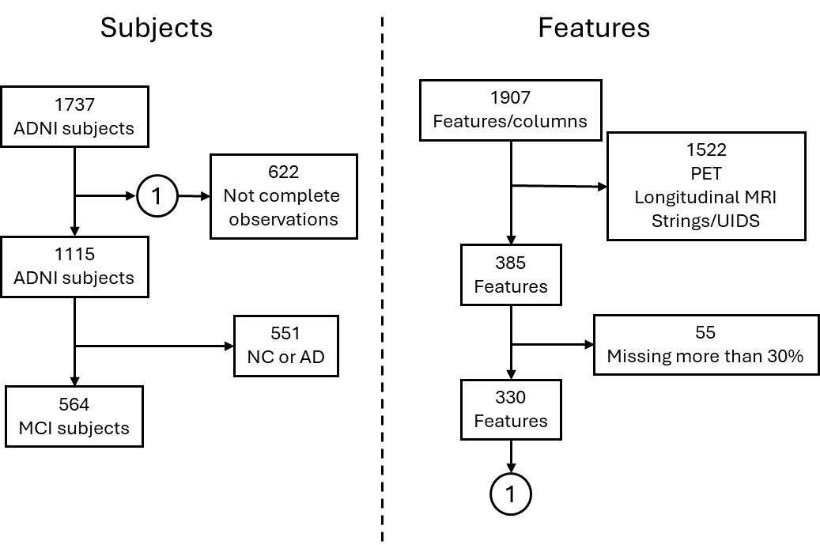

**Figure 1:** Data inclusion and exclusion diagram. Left, subject selection, a baseline of 1737 subjects from ADNI, 622 subjects with missing data or few observations were excluded. 564 subjects with MCI and complete observations were included. Right, Feature selection, 1907 features were identified from ADNI-TADPOLE, 1522 PET, and longitudinal analysis features with Free Surfer were excluded, then features with lost data were excluded to include a total of 330 features per patient.



Figure : Diagram, the process of analysis of discovered biomarkers, data fusion (CSF: cerebrospinal fluid, MRI: magnetic resonance imaging, Cog: Cognitive, APOEε4: apolipoprotein E4) by cross-validation and Machine Learning methods comparison evaluating the performance of 6 Cox models

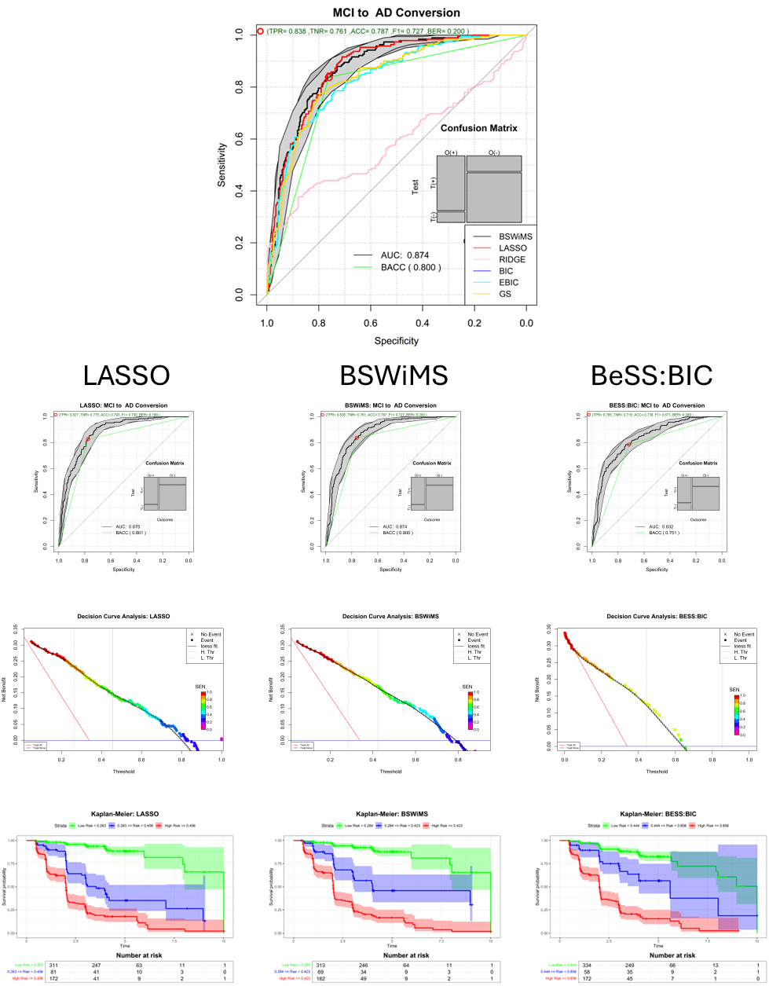

Figure : Top plot, comparison of all ROC curves of all source-experiments. Bottom plots, ROC curves, Decision Curve, and Kaplan-Meier of LASSO, BSWiMS, and BESS BIC.

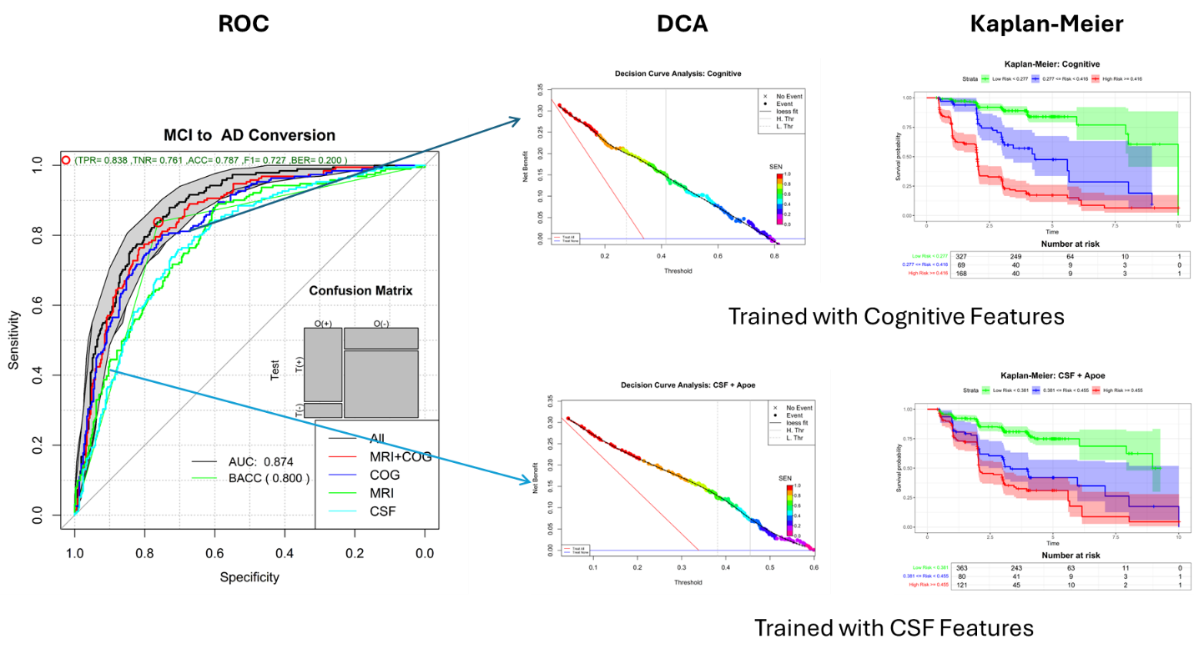

Figure : Left, ROC curves of method comparison experiment. Right, ROC curves of source comparison using the BSWiMS method. Middle and right plots shows the DCA and Kaplan-Meier analysis of the test results for cognitive and CSF models.

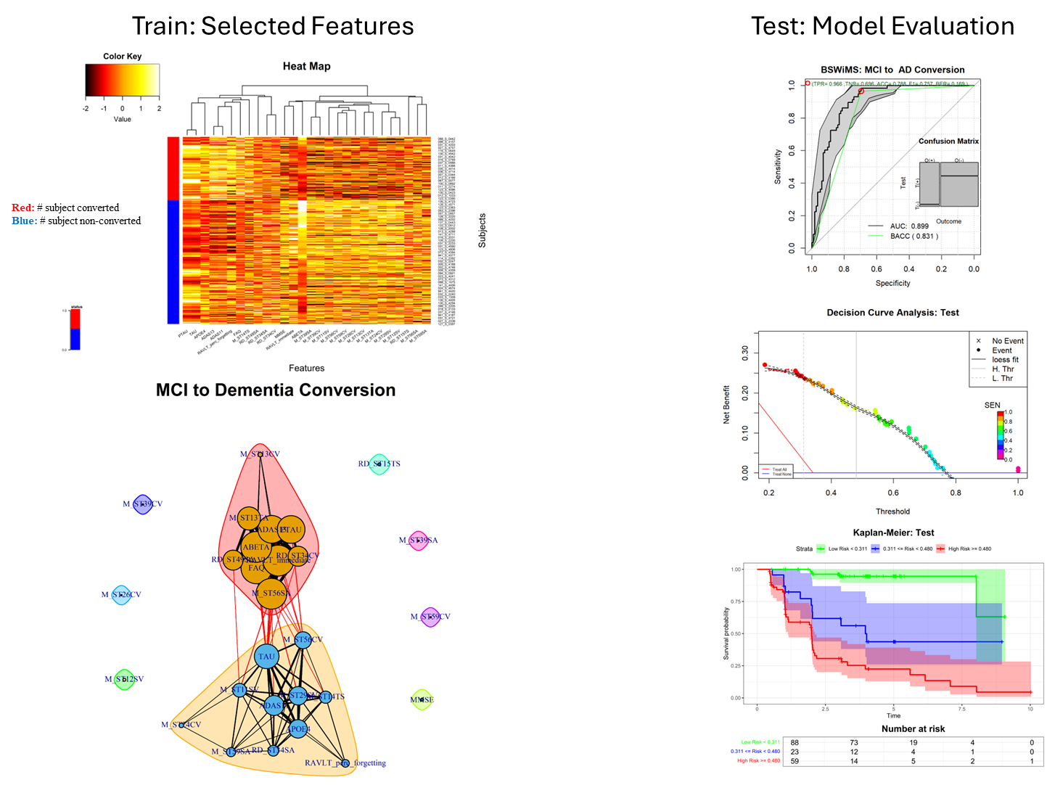

Figure : Top left, the 22 features selected by all the 3 methods in at least in the half of the iterations (vertical axis) and subjects on the horizontal axis. Bottom-left, graph showing the association between Cox-Model features. Left plots, evaluation of the predictions on the testing set. ROC, DCA and Kaplan-Meier plots.

**Table** : List of various abbreviations and acronyms used throughout the paper.

|  |  |
| --- | --- |
| **Abbreviation** | **Definition** |
| Ab | amyloid beta 1-42 |
| ACC | accuracy |
| AD | Alzheimer’s disease |
| ADAS | Alzheimer’s Disease Assessment Scale |
| ADNI | Alzheimer's Disease Neuroimaging Initiative |
| APOE 4 | apolipoprotein E4 |
| AUC | area under the curve |
| BESS | Best subset selection |
| BIC | Bayesian information criterion |
| BSWiMS | Bootstrap Stepwise Model Selection |
| CDRSB | Clinical Dementia Rating Sum of Boxes |
| CI | confidence intervals |
| CSF | cerebrospinal fluid |
| FAQ | Functional Assessment Questionnaire |
| FDR | false discovery rate |
| FS | future selection |
| GPDAS | golden section primal-dual active set |
| HR | hazard ratios |
| ICV | Intracranial volume |
| KM | Kaplan-Meier |
| LASSO | Least Absolute Shrinkage and Selection Operator |
| LIP | Left Inferior Parietal |
| MCI | mild cognitive impairment |
| ML | machine learning |
| MMSE | Mini-Mental State Examination |
| MRI | magneto resonance |
| PET | Positron-emitting tomography |
| p-tau | phosphorylated tau |
| RAVLT | Rey's Auditory Verbal Learning Test |
| RHOCV | repeated holdout cross-validation |
| ROC | receiver operating characteristic |
| SEN | sensitivity |
| SL | Statistical learning |
| SPDAS | sequential primal-dual active set |
| SPE | specificity |
| TADPOLE | The Alzheimer’s Disease Prediction Of Longitudinal Evolution |
| TN | true negative |
| TP | true positive |
| UCSF | University of California San Francisco |

Table : Demographic data with features sectioned by non-converter and converter group.

|  |  |  |  |
| --- | --- | --- | --- |
| Feature | Units/Scale | No Converter (373) | Converter (191) |
| AGE (years) | years | 71.93 (7.65) | 73.53 (7.07)** |
| Gender (M/F) | Male / Female | 217 |156 | 119 | 72 |
| APOEε4 | categoric | 218 |155 | 67 | 124*** |
| MMSE score | 0 - 30 | 28.11 (1.69) | 26.96 (1.79)*** |
| FAQ | 0 - 30 | 1.99 (3.19) | 5.24 (4.68)*** |
| ADAS11 (cognitive score) | 0 - 70 | 8.52 (3.82) | 12.93 (4.64)*** |
| ADAS13 (cognitive score) | 0 - 85 | 13.70 (5.79) | 20.87 (6.22)*** |
| RAVLT immediate | # words | 37.69 (10.71) | 28.59 (7.20)*** |
| RAVLT % forgetting | # words (%) | 52.82 (30.46) | 76.12 (29.11)*** |
| RAVLT learning | # words | 4.80 (2.53) | 3.07 (2.31)*** |
| RAVLT forgetting | # words | 4.52 (2.43) | 5.08 (2.27)*** |
| ABETA | (pg/mL) | 1154.23 (580.01) | 724.01 (325.90)*** |
| TAU | (pg/mL) | 256.44 (117.93) | 342.46 (133.00)*** |
| PTAU | (pg/mL) | 24.27 (13.15) | 34.33 (15.10)*** |
| $\sqrt[3]{ICV}$ | mm | 115.15 (3.95) | 115.65 (4.38) |
| $\sqrt[3]{Whole Brain}$ | mm | 884.40 (21.25) | 868.01 (20.44)*** |
| $\sqrt[3]{Ventricles}$ | mm | 280.03 (49.43) | 296.33 (46.40)*** |

* p<0.05,** p<0.01,*** p<0.001

Table : ML subset selection method comparison

|  |  |  |  |  |  |
| --- | --- | --- | --- | --- | --- |
| **Method** | **ROC AUC** | **c-Index** | **Accuracy** | **Sensitivity** | **Specificity** |
| BSWiMS | 0.87 [0.85,0.90] | 0.85 [0.82,0.87] | 0.81 [0.78,0.84] | 0.69 [0.63,0.76] | 0.87 [0.83,0.90] |
| BESS:BIC | 0.83 [0.80,0.87] | 0.82 [0.79,0.84] | 0.79 [0.75,0.82] | 0.63 [0.56,0.70] | 0.86 [0.83,0.90] |
| BESS:EBIC | 0.83 [0.80,0.87] | 0.82 [0.79,0.84] | 0.79 [0.75,0.82] | 0.63 [0.56,0.70] | 0.86 [0.83,0.90] |
| BESS:GS | 0.84 [0.80,0.87] | 0.82 [0.79,0.85] | 0.79 [0.76,0.82] | 0.63 [0.56,0.70] | 0.87 [0.83,0.90] |
| LASSO | 0.88 [0.85,0.90] | 0.85 [0.82,0.87] | 0.79 [0.75,0.82] | 0.64 [0.57,0.71] | 0.87 [0.83,0.90] |
| RIDGE | 0.54 [0.49,0.58] | 0.57 [0.53,0.61] | 0.56 [0.52,0.60] | 0.48 [0.41,0.55] | 0.61 [0.56,0.66] |

Table : Source Comparison on BSWiMS models

|  |  |  |  |  |  |
| --- | --- | --- | --- | --- | --- |
| **Model** | **ROC AUC** | **c-Index** | **Accuracy** | **Sensitivity** | **Specificity** |
| All | 0.87 [0.85,0.90] | 0.85 [0.82,0.87] | 0.81 [0.78,0.84] | 0.69 [0.63,0.76] | 0.87 [0.83,0.90] |
| Cog + MRI | 0.85 [0.82,0.89] | 0.83 [0.81,0.86] | 0.79 [0.76,0.83] | 0.65 [0.58,0.72] | 0.87 [0.83,0.90] |
| Cog | 0.84 [0.81,0.87] | 0.83 [0.80,0.85] | 0.79 [0.75,0.82] | 0.62 [0.55,0.69] | 0.87 [0.83,0.90] |
| MRI+ APOEε4 | 0.79 [0.75,0.83] | 0.76 [0.73,0.80] | 0.74 [0.70,0.77] | 0.47 [0.40,0.54] | 0.87 [0.84,0.91] |
| CSF+ APOEε4 | 0.78 [0.74,0.82] | 0.73 [0.69,0.76] | 0.72 [0.68,0.76] | 0.40 [0.33,0.47] | 0.88 [0.85,0.92] |

Table : Top Features characteristics that intervene in the conversion of MCI to Alzheimer like relevant biomarkers

|  |  |  |  |  |
| --- | --- | --- | --- | --- |
| **Feature** | **Estimate** | **HR [95%CI]** | **Source** | **Description** |
| **RAVLT_immediate** | -0.344 | 0.527 [0.400,0.695] | Cognitive Function | Rey Auditory Verbal Learning Test: Immediate |
| **FAQ** | 0.246 | 1.581 [1.273,1.963] | Cognitive Function | Functional Activities Questionnaire |
| **ABETA** | -0.208 | 0.679 [0.541,0.853] | CSF | Amyloid Beta |
| **PTAU** | 0.014 | 1.399 [1.165,1.680] | CSF | p-Tau |
| **ADAS13** | 0.124 | 1.501 [1.130,1.993] | Cognitive Function | Alzheimer's Disease Assessment Scale-Cog13 |
| **TAU** | 0.314 | 1.465 [1.224,1.753] | CSF | Tau |
| **ADAS11** | 0.191 | 1.789 [1.463,2.189] | Cognitive Function | Alzheimer's Disease Assessment Scale-Cog11 |
| **M_ST24CV** | -0.102 | 0.689 [0.557,0.852] | qMRI | Mean: Volume (Cortical Parcellation) of LeftEntorhinal |
| **M_ST29SV** | -0.117 | 0.643 [0.500,0.826] | qMRI | Mean: Volume (WM Parcellation) of Left Hippocampus |
| **APOEΕ4** | 0.315 | 2.063 [1.357,3.136] | Genomic | APOEε4 |
| **RAVLT_perc_forgetting** | 0.071 | 1.684 [1.224,2.319] | Cognitive Function | Rey Auditory Verbal Learning Test: forgetting |
| **RD_ST34CV** | -0.089 | 0.779 [0.683,0.888] | qMRI | Relative Dif: Volume (Cortical Parcellation) of Left Isthmus Cingulate |
| **M_ST13TA** | -0.204 | 0.659 [0.572,0.760] | qMRI | Mean: Cortical Thickness Average of Left Bankssts |
| **M_ST26CV** | 0.000 | 0.749 [0.620,0.905] | qMRI | Mean: Volume (Cortical Parcellation) of Left Fusiform |
| **M_ST11SV** | -0.156 | 0.736 [0.625,0.868] | qMRI | Mean: Volume (WM Parcellation) of Left Accumbens Area |
| **M_ST12SV** | -0.037 | 0.711 [0.581,0.869] | qMRI | Mean: Volume (WM Parcellation) of Left Amygdala |
| **M_ST56CV** | -0.023 | 0.782 [0.694,0.881] | qMRI | Mean: Volume (Cortical Parcellation) of Left Superior Frontal |
| **M_ST56SA** | -0.216 | 0.693 [0.586,0.819] | qMRI | Mean: Surface Area of Left Superior Frontal |
| **M_ST39CV** | 0.000 | 0.873 [0.814,0.936] | qMRI | Mean: Volume (Cortical Parcellation) of Left Medial Orbitofrontal |
| **MMSE** | -0.040 | 0.745 [0.610,0.911] | Cognitive Function | Mini-Mental State Examination |
| **M_ST59CV** | 0.000 | 0.780 [0.693,0.876] | qMRI | Mean: Volume (Cortical Parcellation) of Left Supramarginal |
| **RD_ST15TS** | -0.060 | 0.773 [0.661,0.903] | qMRI | Relative Dif: Cortical Thickness Standard Deviation of Left Caudal Middle Frontal |
| **M_ST13CV** | 0.000 | 0.786 [0.682,0.907] | qMRI | Mean: Volume (Cortical Parcellation) of Left Bankssts |
| **M_ST14TS** | 0.059 | 1.252 [1.094,1.433] | qMRI | Mean: Cortical Thickness Standard Deviation of Left Caudal Anterior Cingulate |
| **M_ST59SA** | -0.085 | 0.754 [0.645,0.883] | qMRI | Mean: Surface Area of Left Supramarginal |
| **RD_ST49SA** | -0.087 | 0.804 [0.699,0.925] | qMRI | Relative Dif: Surface Area of Left Postcentral |
| **RD_ST34SA** | -0.102 | 0.750 [0.619,0.911] | qMRI | Relative Dif: Surface Area of Left Isthmus Cingulate |
| **M_ST39SA** | 0.000 | 0.940 [0.904,0.978] | qMRI | Mean: Surface Area of Left Medial Orbitofrontal |